QR-Based Job Record and Management System
HNDIT1052 ICT Project (Individual)
Final Report

By:
D.G.D.D. Dasanayaka
RAT/IT/2324/F/0017

A report submitted in partial fulfillment of the requirements for the higher national diploma in Information Technology

Name of the Supervisor(s):
G.S.T. Bandara
Chamal Atukorala
Yasitha Dissanayake

Department of Information Technology
Advanced Technological Institute
Ratnapura
2024

Declaration

We declare that this thesis is our own work and has not been submitted in any form for another degree or diploma at any university or other institution of tertiary education. Information derived from the published or unpublished work of others has been acknowledged in the text and a list of references is given.

Name of Student Signature of Student
- D.G.D.D. Dasanayaka

Date:
--------------------------------

Supervised by:

Name of Supervisor(s) Signature of Supervisor(s)
- G.S.T. Bandara
- Chamal Atukorala
- Yasitha Dissanayake

Date:
--------------------------------

Dedication

To the visionaries, the creators, and the unsung heroes who believe in the power of collaboration and the freedom of knowledge:

This project is dedicated to the countless individuals and communities who tirelessly contribute to the world of free and open-source software. Your selfless efforts, innovative spirit, and unwavering commitment to accessibility have transformed the way we learn, create, and connect.

You have given us tools that empower, inspire, and unite. You have shown us that technology can be a force for good, built not for profit, but for people. Your work is a testament to the belief that knowledge should be shared, not hoarded, and that together, we can build a better, more inclusive future.

Thank you for paving the way, for breaking down barriers, and for reminding us that the greatest innovations are born from generosity and collaboration. This project stands on the shoulders of your dedication, and it is a humble tribute to your enduring legacy.

With gratitude and respect,
D.G.D.D. Dasanayaka

Acknowledgements

I extend my sincere gratitude to my supervisors for their expert guidance, insightful feedback, and unwavering support throughout this project. To my friends and colleagues, thank you for your encouragement, collaboration, and shared ideas. Lastly, I am deeply thankful to my family for their constant support, patience, and belief in me. This accomplishment is a reflection of the collective effort and encouragement I have received from all of you.

Thank you

Abstract

Managing job records manually is a time-consuming and error-prone process, particularly in businesses like automobile repair shops, where efficiency is critical. Deshapriya Motors, an automobile service provider, currently relies on paper-based records to track daily jobs, employee workload, and incentive calculations. This method leads to challenges such as delayed record-keeping, difficulty in retrieving job history, and inconsistencies in calculating employee incentives. To address these inefficiencies, this project proposes a QR-Based Job Record and Management System, which integrates digital tools to automate job tracking and data management.

The system is designed for employees and management to simplify job entry, record-keeping, and performance tracking. Each job entry is initiated by scanning a QR code, which directs users to a Google Form pre-filled with relevant job details. Employees submit job data through this form, and responses are automatically recorded in Google Sheets. A daily downloaded copy of the spreadsheet is linked to an MS Access database, where structured queries process and organize data for reporting and decision-making. This enables efficient job tracking, real-time monitoring, and accurate incentive calculations, eliminating the dependency on handwritten records.

The project follows a structured approach in analysis and design, identifying system requirements, workflows, and user interactions. The implementation phase involves integrating QR code generation, form submission, data synchronization, and database operations. The system is then evaluated for accuracy, efficiency, and user-friendliness, ensuring it meets business requirements.

By replacing manual record-keeping with a cost-effective digital solution, this system improves job tracking, enhances employee motivation through transparent incentive calculations, and streamlines overall management at Deshapriya Motors. The project demonstrates how leveraging simple digital tools can create an efficient, low-cost, and scalable solution for small businesses.

Table Of Contents

Contents
Declaration i
Dedication ii
Acknowledgements iii
Abstract iv
Table Of Contents v
List of Figures vi
Chapter 1: Introduction 1
1.1 Project Overview 1
1.2 Objectives 2
Chapter 2: Tools and Technologies Used 3
2.1 Software and Tools 3
2.2 Justification of Tools 4
Chapter 3: Project Design and Development Process 5
3.1 Planning 5
3.2 Development Steps 6
3.3 Challenges Faced 9
Chapter 4: Key Features and Functions 10
4.1 Feature Summary 10
4.2 Screenshots and Illustrations: 14
Chapter 5: Results and Testing 15
5.1 Final Outcome 15
5.2 Testing and Feedback: 16
5.2.1 Feedback and Observations: 17
Chapter 6: Conclusion 18
6.1 Summary 18
6.2 Future Improvements 20
6.2.1 Final Remarks 22
Chapter 7: References 23

List of Figures

Figure A 2
Figure B 6
Figure C 7
Figure D 7
Figure E 8
Figure F 10
Figure G 11
Figure H 11
Figure I 12
Figure J 12
Figure K 13
Figure L 14

Chapter 1: Introduction

1.1 Project Overview

Managing job records manually in a growing automobile repair shop can be inefficient, error-prone, and time-consuming. Deshapriya Motors, an authorized service center, currently relies on handwritten records to track daily jobs, monitor employee performance, and calculate incentives. This manual system makes it difficult to retrieve job histories, track work progress, and ensure fair compensation for employees.

The QR-Based Job Record and Management System is designed to streamline and digitize the job tracking process using QR codes, Google Forms, Google Sheets, and MS Access. The system generates unique QR codes linked to pre-filled job entry forms, which employees can scan using their smartphones or shop-provided devices. Job details are then submitted through Google Forms, and all responses are automatically recorded in Google Sheets. A daily downloaded copy of the data is linked to an MS Access database, where queries and automated processes extract relevant information for reporting, performance tracking, and incentive calculations.

This system aims to reduce paperwork, improve efficiency, and ensure accurate job record management while utilizing low-cost digital tools. By eliminating the dependency on manual record-keeping, it enhances transparency, accountability, and decision-making for both management and employees.

1.2 Objectives

The primary objectives of this project are:

- To digitize the job recording process – Implement a system that allows employees to enter job details using QR codes and Google Forms, reducing reliance on paper records.
- To automate data collection and storage – Utilize Google Sheets and MS Access for structured data storage, ensuring easy retrieval and accuracy.
- To improve job tracking and efficiency – Provide a clear and organized system for monitoring ongoing and completed jobs.
- To facilitate employee performance evaluation and incentive calculation – Automate the process of tracking completed jobs and calculating incentives based on predefined criteria.
- To develop a cost-effective and scalable solution – Design a system that runs on existing resources with minimal additional investment.

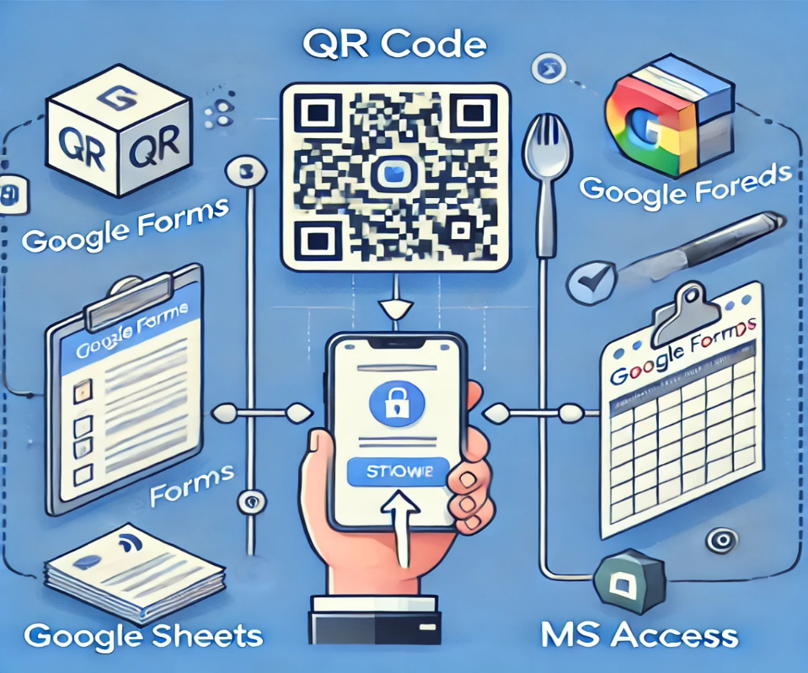
By achieving these objectives, the project aims to modernize job tracking at Deshapriya Motors, enhance employee motivation, and improve overall operational efficiency.

Figure A
Chapter 2: Tools and Technologies Used

2.1 Software and Tools

The QR-Based Job Record and Management System leverages a combination of free and low-cost digital tools to ensure efficiency, affordability, and ease of implementation. The following software and tools have been used:

- Google Sheets – Acts as the primary database for storing job records, employee performance data, and incentive tracking.
- Google Forms – Provides a structured way for employees to submit job details using pre-filled QR code links.
- Google Apps Script – Automates QR code generation, form integration, and data management in Google Sheets.
- MS Access – Used for data processing, querying, and report generation by linking the downloaded daily job records from Google Sheets.
- QR Code API (Google Charts API or an open-source alternative) – Generates unique QR codes dynamically for job tracking.
- Web Technologies (HTML, CSS, JavaScript) – Supports a simple web interface to display QR codes and assist employees in accessing job forms.
- Microsoft Office (Word, Excel, PowerPoint) – Used for documentation, reporting, and presentation of project findings.

This combination of cloud-based tools and locally installed software ensures a cost-effective, scalable, and user-friendly system that requires minimal additional hardware or software investments.

2.2 Justification of Tools

The selection of these tools was based on key considerations, including minimal capital investment, accessibility, ease of use, and automation capabilities.

- Cost-effectiveness – The project primarily utilizes free and open-source tools, such as Google Sheets and Google Forms, reducing the need for expensive software solutions. MS Access, although a paid tool, is chosen for its offline capabilities and integration with existing business workflows.
- Cloud-based accessibility – Google Workspace tools provide a real-time, collaborative environment where job records are automatically updated, accessible from multiple devices, and securely stored.
- Automation and efficiency – Google Apps Script automate the QR code generation and data handling, reducing manual workload and potential errors.
- Ease of use and adoption – The tools selected are familiar to most users, reducing training time and ensuring smooth implementation. Employees only need to scan a QR code and submit a form, making the system intuitive and user-friendly.
- Scalability – The system can be expanded or integrated with additional tools in the future without requiring a major overhaul.

By leveraging free and existing resources, this project ensures that Deshapriya Motors gains an efficient digital solution without incurring high costs, making it an ideal technology-driven upgrade for small businesses.

Chapter 3: Project Design and Development Process

3.1 Planning

Before starting this project, I leveraged my prior experience working at Deshapriya Motors to gain a foundational understanding of the existing job recording and management processes. However, to ensure an accurate and detailed grasp of the challenges, I conducted further observations of the service center’s workflow.

Through this, I identified several inefficiencies, including manual record-keeping, human errors, potential biases in incentive calculations, and personality conflicts among employees.

With these observations in mind, I mentally designed a rough framework of the system, considering the available tools and technologies. My focus was to create a system that minimized additional resource requirements, ensuring affordability and ease of adoption.

Without extensive pre-planning documentation, I opted for an iterative approach, beginning development immediately and refining the system as challenges arose.

3.2 Development Steps

The development process followed a dynamic, problem-solving approach, consisting of the following key steps:

1. Initial Conceptualization and Tool Selection
- Based on my observations, I initially considered using an open-source asset management framework called Snipe-IT for the system.
- I researched various database solutions and methods for integrating QR code-based job tracking.

Figure B

2. Testing Snipe-IT for the System
- Attempted installation and configuration of Snipe-IT on a server.
- Encountered compatibility issues, hosting difficulties, and excessive configuration requirements.
- Realized that Snipe-IT’s capabilities were beyond the scope of the project and that maintaining the system would require continuous intervention.

3. Transition to Google Sheets and Google Forms
- Created the initial job record submission system using Google Forms.
- Researched and successfully implemented dynamic QR code generation within Google Sheets.
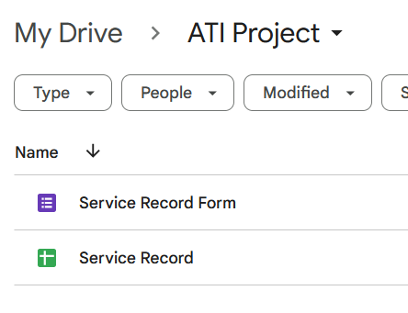
Figure C

4. Linking Google Sheets to MS Access
- Planned to directly integrate Google Sheets with MS Access for data processing and reporting.
- Encountered difficulties with available ODBC drivers, which were mostly paid, and lacked the technical knowledge to develop a custom driver.
- Opted for an alternative approach, manually downloading Google Sheets data and linking it to Access using a replaceable file system.
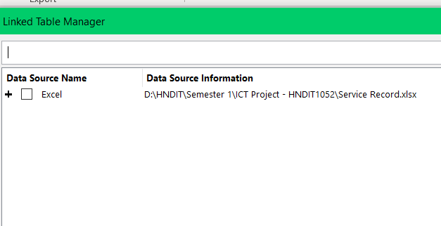
Figure D

5. Optimization and Refinement
- Streamlined Google Sheets data organization for better efficiency.
- Designed queries and reports in MS Access to extract meaningful insights from job records.
- Customized sheets and optimized the process to minimize manual intervention.

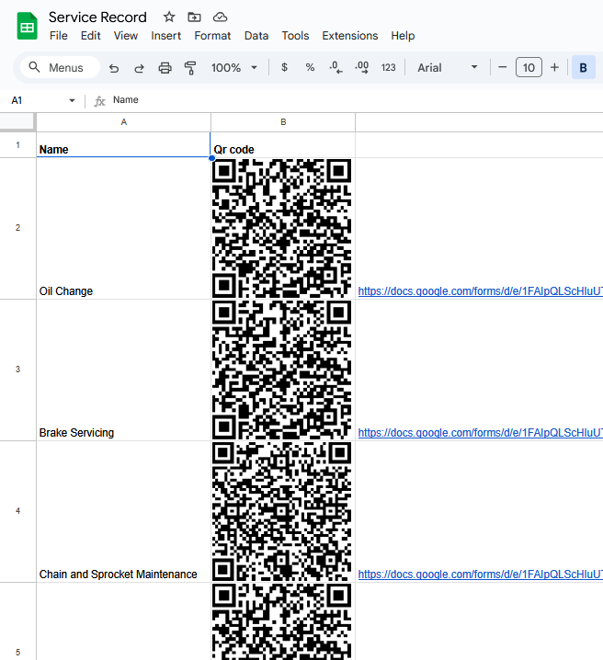
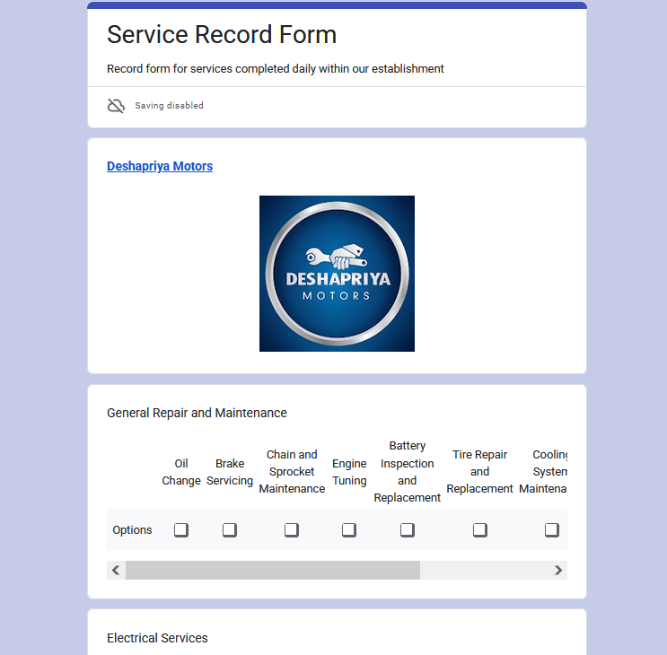

Figure E

3.3 Challenges Faced

The development process was met with several hurdles that required adaptive problem-solving:

  - Choosing the Right Platform:
The initial choice of Snipe-IT proved unsuitable due to complex installation, hosting challenges, and unnecessary features beyond the project’s needs. The transition to Google Forms and Sheets streamlined the process significantly.
  - Integration Issues:
Connecting Google Sheets to MS Access in real time was hindered by paid ODBC drivers. The manual file-replacement method was chosen as a practical workaround.
  - Data Organization and Optimization:
It took multiple iterations to refine the Google Sheets structure to ensure smooth data handling and efficient record-keeping.
  - Technical Learning Curve:
While developing the system, I had to self-learn several aspects, including QR code generation, Google Apps Script, and MS Access query optimization.

Despite these challenges, the system evolved into a streamlined, low-cost solution that effectively meets the requirements of Deshapriya Motors. The iterative development process allowed for continuous improvements, ultimately resulting in a functional and practical job record and management system.

Chapter 4: Key Features and Functions

4.1 Feature Summary

The QR-Based Job Record and Management System offers several key features designed to streamline job tracking and data management at Deshapriya Motors. These features include:

1. QR Code Generation:
Each job is assigned a unique QR code, generated dynamically using Google Apps Script and a QR Code API. This QR code links to a pre-filled Google Form for job entry.
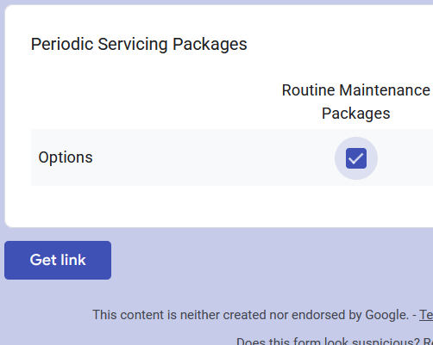

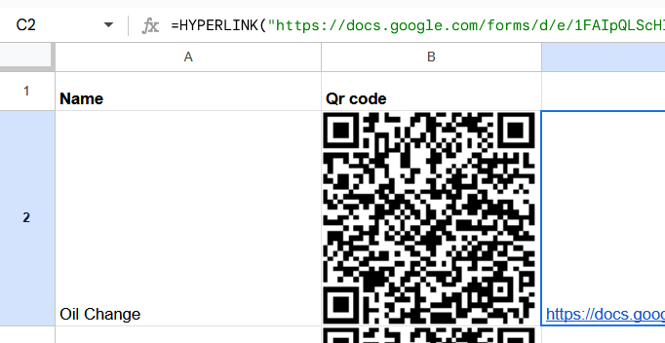
Figure F

2. Job Entry via Google Forms:
Employees can scan the QR code using their smartphones or shop-provided devices to access a Google Form. The form is pre-filled with relevant job details, simplifying the data entry process.
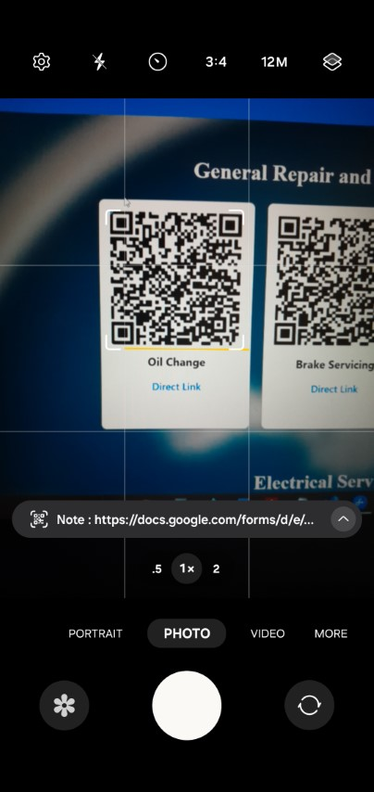

Figure G

3. Automated Data Collection:
Job details submitted through Google Forms are automatically recorded in Google Sheets, ensuring real-time data collection and reducing manual entry errors.
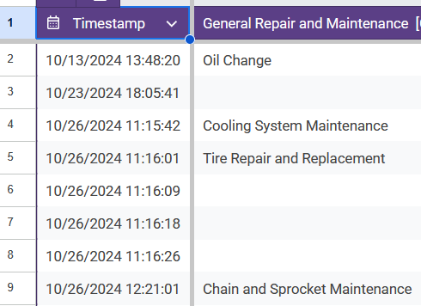
Figure H

4. Data Synchronization with MS Access:
A daily downloaded copy of the Google Sheets data is linked to an MS Access database. This allows for structured data processing, querying, and report generation.
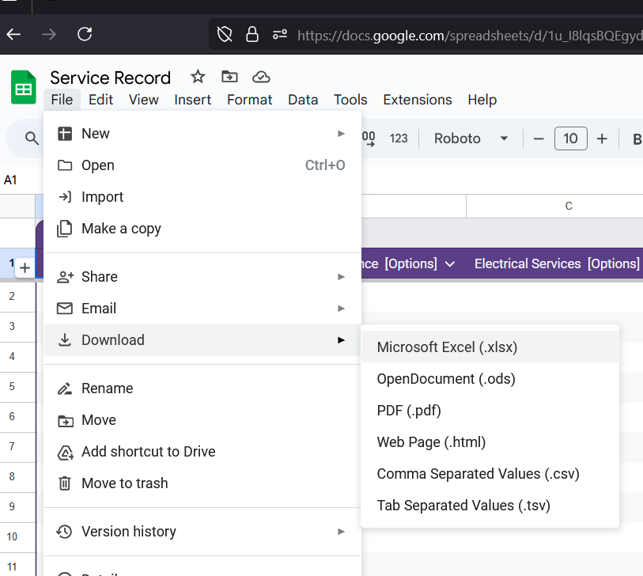
Figure I

5. Performance Tracking and Incentive Calculation:
The system includes automated processes in MS Access to track employee performance and calculate incentives based on predefined criteria, ensuring transparency and accuracy.
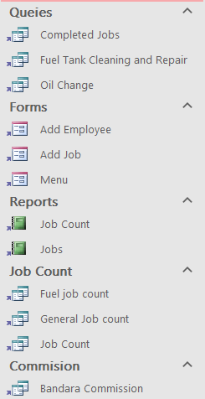
Figure J

6. User-Friendly Interface:
The system leverages familiar tools like Google Forms and Sheets, making it easy for employees to adopt and use with minimal training.

7. Cost-Effective and Scalable:
By utilizing free and low-cost tools, the system is affordable and can be scaled or integrated with additional tools in the future without significant investment.


Figure K

4.2 Screenshots and Illustrations:

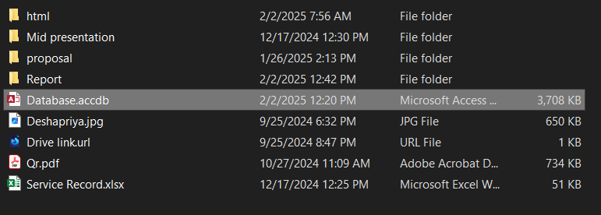

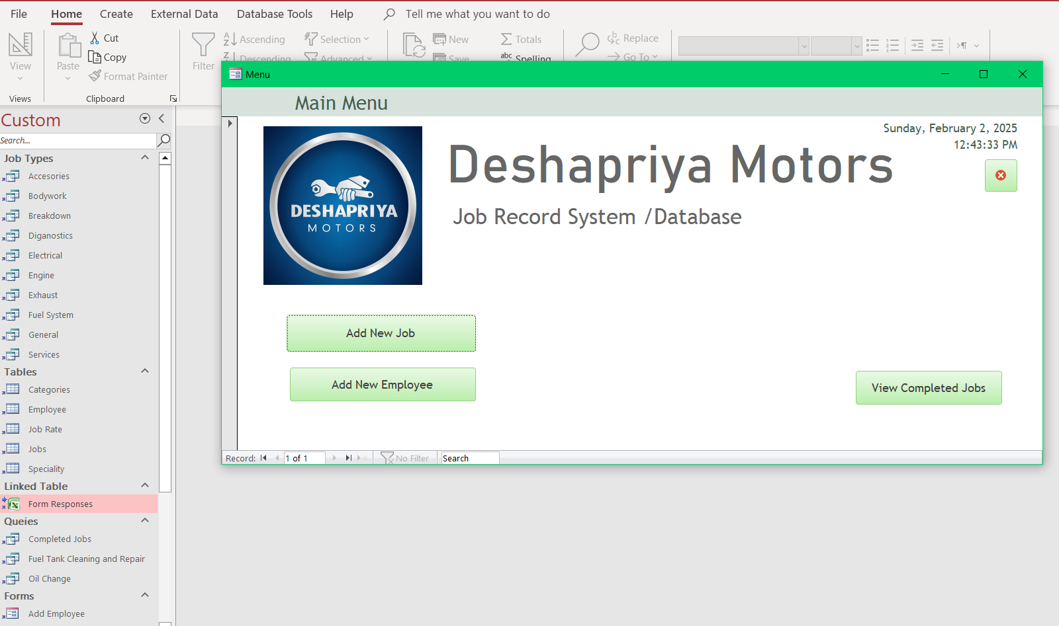

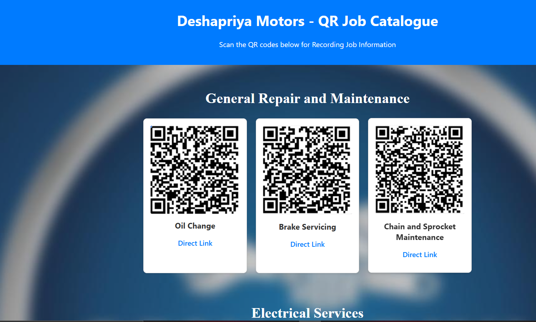

Figure L

Chapter 5: Results and Testing

5.1 Final Outcome

The QR-Based Job Record and Management System successfully digitized the job tracking process at Deshapriya Motors. The final outcome of the project includes the following key achievements:

- Efficient Job Tracking:
The system enables employees to easily enter job details using QR codes and Google Forms. This significantly reduces the time and effort required for manual record-keeping, streamlining the overall workflow.

- Automated Data Management:
Job data is automatically collected in Google Sheets and synchronized with MS Access for structured processing and reporting. This ensures that records are accurate, up-to-date, and easily accessible for analysis.

- Enhanced Performance Evaluation:
The system provides tools for tracking employee performance and calculating incentives based on predefined criteria. This promotes transparency and fairness in evaluating employee contributions.

- User-Friendly Interface:
By utilizing familiar tools like Google Forms and Sheets, the system ensures that employees can quickly adapt to the new process with minimal training. This reduces the learning curve and increases adoption rates.

- Cost-Effective Solution:
The system leverages free and low-cost digital tools, making it a scalable and affordable solution for small businesses like Deshapriya Motors. It eliminates the need for expensive software or hardware investments.

5.2 Testing and Feedback:

The project was rigorously tested in a real-world environment at Deshapriya Motors to evaluate its functionality, reliability, and effectiveness. The testing process involved the following steps:

- Initial Deployment: The system was deployed in a controlled environment, with a select group of employees using the QR code-based job entry system for a trial period. This allowed for real-world testing and identification of potential issues.

- Data Accuracy Verification: The accuracy of data collected through Google Forms and recorded in Google Sheets was verified by cross-referencing it with existing manual records. This step ensured that the system-maintained data integrity and reliability.

- Performance Tracking and Incentive Calculation: The automated processes in MS Access for performance tracking and incentive calculation were tested to ensure they produced accurate and consistent results. This was critical for maintaining trust in the system.

- User Feedback: Employees and management provided feedback on the system's usability, efficiency, and overall impact on their workflow. This feedback was invaluable for identifying strengths and areas for improvement.

5.2.1 Feedback and Observations:

- Positive Feedback: Employees appreciated the ease of use and the significant reduction in paperwork. They found the QR code-based entry system intuitive and time-saving. Management noted improvements in the accuracy of job records and incentive calculations, which enhanced decision-making processes.

- Areas for Improvement: Some employees suggested additional training sessions to help them fully familiarize themselves with the new system. Management recommended further optimization of data synchronization between Google Sheets and MS Access to ensure seamless integration and reduce any delays in data processing.

In conclusion he testing phase demonstrated that the QR-Based Job Record and Management System effectively addressed the inefficiencies of manual record-keeping. It provided a streamlined, accurate, and user-friendly solution for job tracking and data management at Deshapriya Motors. The positive feedback from employees and management, along with the successful resolution of identified issues, confirmed the system's potential to transform the company's operations. Future work will focus on addressing the feedback and further enhancing the system's capabilities to ensure long-term success.

Chapter 6: Conclusion

6.1 Summary

The QR-Based Job Record and Management System project was designed to address the inefficiencies and challenges associated with manual job tracking at Deshapriya Motors. By leveraging digital tools such as QR codes, Google Forms, Google Sheets, and MS Access, the project successfully digitized the job recording process, resulting in several key achievements:

- Streamlined Job Tracking: The system enabled employees to enter job details quickly and accurately using QR codes and Google Forms. This eliminated the need for cumbersome paperwork and significantly reduced the time and effort required for manual record-keeping. Employees could now scan QR codes to access job details and update records in real-time, ensuring a seamless workflow.

- Automated Data Management: Job data was automatically collected and organized in Google Sheets, and synchronized with MS Access for structured processing and reporting. This automation minimized human errors and ensured that records were always up-to-date and easily accessible for analysis. The integration between Google Sheets and MS Access allowed for efficient data handling and improved decision-making.

- Enhanced Performance Evaluation: The system provided tools for tracking employee performance and calculating incentives based on predefined criteria. This promoted transparency and fairness in the workplace, as employees could clearly see how their performance was being evaluated and rewarded. The automated incentive calculation feature also reduced the administrative burden on management.

- User-Friendly Interface: The use of familiar tools like Google Forms and Sheets ensured that employees could quickly adapt to the new system with minimal training. The intuitive design of the system made it easy for employees to navigate and use, reducing resistance to change and increasing adoption rates.

- Cost-Effective Solution: By utilizing free and low-cost digital tools, the project offered a scalable and affordable solution for small businesses like Deshapriya Motors. This demonstrated how simple digital tools could create significant improvements in operational efficiency without requiring substantial financial investment.

Overall, the project successfully addressed the key challenges of manual job tracking, providing a streamlined, accurate, and user-friendly solution that enhanced job record management and employee motivation at Deshapriya Motors. The system not only improved operational efficiency but also fostered a more transparent and data-driven work environment.

6.2 Future Improvements

While the QR-Based Job Record and Management System achieved its primary objectives, there are several areas for future improvements and additional features that could further enhance its functionality and effectiveness:

- Real-Time Data Synchronization: Implementing a real-time data synchronization mechanism between Google Sheets and MS Access would eliminate the need for manual data downloads and ensure that the database is always up-to-date with the latest job records. This would further streamline the workflow and reduce delays in data processing.

- Advanced Reporting and Analytics: Adding advanced reporting and analytics capabilities to the system would provide deeper insights into job performance, employee productivity, and overall business operations. This could include visual dashboards, trend analysis, and predictive analytics, enabling management to make more informed decisions and identify areas for improvement.

- Mobile Application: Developing a dedicated mobile application for the system would enhance accessibility and convenience for employees, allowing them to enter job details and track performance directly from their smartphones. This would be particularly beneficial for employees who are frequently on the move or working in remote locations.

- Integration with Other Business Systems: Integrating the job record management system with other business systems, such as inventory management and customer relationship management (CRM) software, would provide a more comprehensive solution for managing all aspects of the business. This integration would enable seamless data flow between different departments and improve overall operational efficiency.

- Enhanced Security Features: Implementing enhanced security features, such as user authentication and data encryption, would ensure that sensitive job records and employee information are protected from unauthorized access and potential data breaches. This would help build trust in the system and ensure compliance with data protection regulations.

- Automated Notifications and Reminders: Adding automated notifications and reminders for pending jobs, performance reviews, and incentive calculations would help ensure that important tasks are not overlooked and are completed in a timely manner. This feature would improve accountability and help employees stay on top of their responsibilities.

- Scalability for Larger Operations: As Deshapriya Motors grows, the system can be scaled to accommodate a larger workforce and more complex job tracking requirements. This could involve adding multi-user support, advanced role-based access controls, and support for multiple locations or departments.

- Training and Support Resources: To ensure continued success, the system could include built-in training modules and support resources for employees. This would help new hires quickly get up to speed and ensure that all users are making the most of the system's features.

By incorporating these future improvements and additional features, the QR-Based Job Record and Management System could further enhance its value and effectiveness, providing an even more robust and comprehensive solution for job tracking and data management at Deshapriya Motors. These enhancements would not only improve operational efficiency but also support the company's growth and adaptability in an increasingly digital and competitive business environment.

6.2.1 Final Remarks

The QR-Based Job Record and Management System has proven to be a transformative solution for Deshapriya Motors, addressing the inefficiencies of manual job tracking and introducing a streamlined, accurate, and user-friendly approach to data management. The project's success highlights the potential of digital tools to drive operational improvements and foster a more transparent and motivated workplace. As the system continues to evolve with future enhancements, it will serve as a cornerstone for Deshapriya Motors' ongoing efforts to innovate and excel in its operations.

Chapter 7: References

- Google Workspace Documentation
  - Google Forms Help Center. (n.d.). Create and manage forms. Retrieved from https://support.google.com/docs/answer/87809
  - Google Sheets Help Center. (n.d.). Get started with Google Sheets. Retrieved from https://support.google.com/docs/answer/6000292

- Microsoft Access Documentation
  - Microsoft Support. (n.d.). Introduction to Access databases. Retrieved from https://support.microsoft.com/en-us/access
  - Microsoft Access Tutorial. (n.d.). Creating and managing databases. Retrieved from https://www.microsoft.com/en-us/microsoft-365/access

- QR Code Technology
  - Denso Wave. (n.d.). QR Code essentials. Retrieved from https://www.qrcode.com/en/
  - QR Code Generator. (n.d.). How QR codes work. Retrieved from https://www.qr-code-generator.com/

- Data Synchronization Techniques
  - Google Developers. (n.d.). Google Sheets API documentation. Retrieved from https://developers.google.com/sheets/api

- Additional Tools and Resources
  - Tutorials in Technical tools.
Retrieved from https://youtube.com/
  - Html learning supplementation.
Retrieved from https://www.w3schools.com/

